|  |
| --- |
| FYP-1 |
| Zabdesk AI Chat bot |
| Monthly deliverable M-2 |

|  |
| --- |
| Izrum  12-16-2020  Advisor: Sir |

USE CASE DIAGRAM:

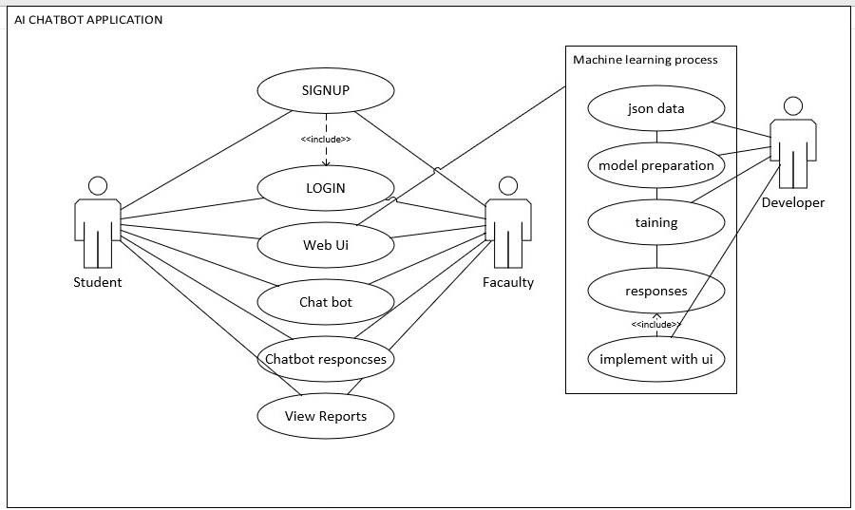

USE CASES:

|  |  |  |  |  |
| --- | --- | --- | --- | --- |
| **Use case Id: Zabdesk Web UI** | | | | |
| **Use case Id:** | | 1 | | |
| **Actors:** Student Faculty | | | | |
| **Feature:** Zabdesk Web UI | | | | |
| **Pre-condition:** | | *User must authentic to interact* | | |
| **Scenarios** | | | | |
| **Step#** | **Action** | | | **Software Reaction** |
| **1.** | User interact with web site and use new feature | | |  |
| **2.** | *User get responsiveness and better UI* | | | *Show light weight and smooth response* |
|  |  | | |  |
| **Alternate Scenarios:** | | | | |
| **1a:** Work fine and responsive    **2a:** UI is not working properly | | | | |
| **Post Conditions** | | | | |
| **Step#** | **Description** | | | |
| **1.** | *Better respond* | | | |
| **2.** | *Web must be interact other services* | | | |
|  |  | | | |
| **Use Case Cross referenced** | | | - | |

|  |  |  |  |  |
| --- | --- | --- | --- | --- |
| **Use case Id: Chat UI** | | | | |
| **Use case Id:** | | 2 | | |
| **Actors:** User and Faculty | | | | |
| **Feature:** Chat UI | | | | |
| **Pre-condition:** | | *User must authenticate* | | |
| **Scenarios** | | | | |
| **Step#** | **Action** | | | **Software Reaction** |
| **1.** | *Authentic user* | | | *Welcome message from chat ui* |
| **2.** | *User interact with UI* | | | Returns a response |
| **3.** | *Interact more academic related question* | | | *Valid Response* |
| **4.** | *Invalid question* | | | *Responded to with alternate response* |
|  |  | | |  |
| **Alternate Scenarios:** Write additional, optional, branching or iterative steps. Refer to specific action number to ensure understandability. | | | | |
| **1a:** Not give a response    **2a:** not interact | | | | |
| **Post Conditions** | | | | |
| **Step#** | **Description** | | | |
| **1.** | *Get interact* | | | |
|  |
|  |  | | | |
| **Use Case Cross referenced** | | |  | |

|  |  |  |  |  |
| --- | --- | --- | --- | --- |
| **Use case Id: Dataset** | | | | |
| **Use case Id:** | | 3 | | |
| **Actors:** Developer | | | | |
| **Feature:** questions and responses | | | | |
| **Pre-condition:** | | *research* | | |
| **Scenarios** | | | | |
| **Step#** | **Action** | | | **Software Reaction** |
| **1.** | *Valid data set and in json form* | | |  |
| **2.** | *Tags and patterns* | | |  |
|  |  | | |  |
|  |  | | |  |
| **Alternate Scenarios:** | | | | |
| **1a:** doesn’t in a json form and not patterns and tags | | | | |
| **Post Conditions** | | | | |
| **Step#** | **Description** | | | |
| **1.** | Valid json form | | | |
|  |  | | | |
| **Use Case Cross referenced** | | | - | |

|  |  |  |  |  |
| --- | --- | --- | --- | --- |
| **Use case Id: Text Preprocessing** | | | | |
| **Use case Id:** | | *4* | | |
| **Actors:** Developer | | | | |
| **Feature:** Text Preprocess | | | | |
| **Pre-condition:** | | Json Dataset and must have tags and patterns | | |
| **Scenarios** | | | | |
| **Step#** | **Action** | | | **Software Reaction** |
| **1.** | *Valid data set and in json form* | | | Create a unique word in the pattern to create a bag of words |
| **2.** | *Tags and patterns* | | | We have got the words in list then perform the stemming |
|  |  | | | Stemming remove all the suffixes and prefixes of a word |
|  |  | | |  |
| **Alternate Scenarios:** | | | | |
| **1a:** doesn’t in a json form and not patterns and tags and stemming not perform | | | | |
| **Post Conditions** | | | | |
| **Step#** | **Description** | | | |
| **1.** | Valid json form | | | |
| **2.** | Get the unique word of list | | | |
| **Use Case Cross referenced** | | | - | |

|  |  |  |  |  |
| --- | --- | --- | --- | --- |
| **Use case Id: Vectorization** | | | | |
| **Use case Id:** | | *5* | | |
| **Actors:** Developer | | | | |
| **Feature:** Vectorization | | | | |
| **Pre-condition:** | | Data must be preprocess | | |
| **Scenarios** | | | | |
| **Step#** | **Action** | | | **Software Reaction** |
| **1.** | Valid data set and in json form | | |  |
| **2.** | Tags and patterns | | |  |
| ***3*** | Text Preprocess | | | Preprocess data convert into accept numerical inputs |
|  |  | | | Feed the numerical input to the neural network |
| **Alternate Scenarios:** | | | | |
| **1a:** doesn’t in a json form or data not preprocess | | | | |
| **Post Conditions** | | | | |
| **Step#** | **Description** | | | |
| **1.** | Valid json form | | | |
| **2.** | Text preprocess and word of list into stem form | | | |
| **Use Case Cross referenced** | | | - | |

|  |  |  |  |  |
| --- | --- | --- | --- | --- |
| **Use case Id: Modeling** | | | | |
| **Use case Id:** | | *6* | | |
| **Actors:** Developer | | | | |
| **Feature:** Modeling | | | | |
| **Pre-condition:** | | Text Preprocess and stem to | | |
| **Scenarios** | | | | |
| **Step#** | **Action** | | | **Software Reaction** |
| **1.** | Valid data set and in json form | | |  |
| **2.** | Tags and patterns | | |  |
| ***3*** | Text Preprocess and vectorize | | | Feed our process data into fc layer and regression |
|  |  | | |  |
| **Alternate Scenarios:** | | | | |
| **1a:** doesn’t in a json form or data not preprocess | | | | |
| **Post Conditions** | | | | |
| **Step#** | **Description** | | | |
| **1.** | Valid json form | | | |
| **2.** | Data is vectorized | | | |
| **Use Case Cross referenced** | | | - | |

|  |  |  |  |  |
| --- | --- | --- | --- | --- |
| **Use case Id: Integration** | | | | |
| **Use case Id:** | | *6* | | |
| **Actors:** Developer | | | | |
| **Feature:** Integration | | | | |
| **Pre-condition:** | | Model file created | | |
| **Scenarios** | | | | |
| **Step#** | **Action** | | | **Software Reaction** |
| **1.** | Model file created | | | Model integrate into frontend through ajax and JavaScript |
|  |  | | |  |
|  |  | | |  |
|  |  | | |  |
| **Alternate Scenarios:** | | | | |
| **1a:** Model file didn’t create file | | | | |
| **Post Conditions** | | | | |
| **Step#** | **Description** | | | |
| **1.** | Valid json form | | | |
| **2.** | Model is create | | | |
| **Use Case Cross referenced** | | | - | |

AI/ML Algorithm and methods:

We have to take the “tag” and “patterns” and store in the list and take the collection of unique words then create the bag of words vector for vectorization and pass it through the Lancaster streamer, saved into a file and then take the preprocessing file and use natural language processing methods to get make layers and get the target probabilities

SEQUENCE DIAGRAM:

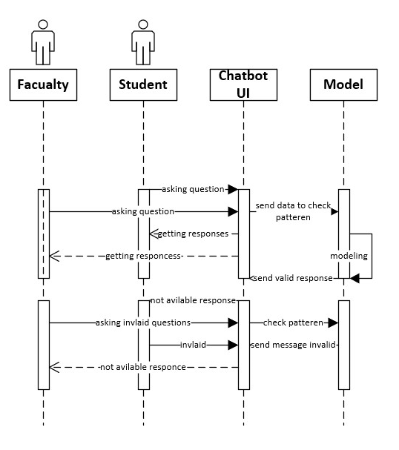

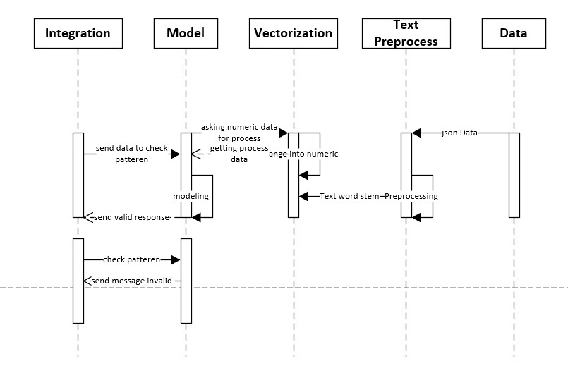

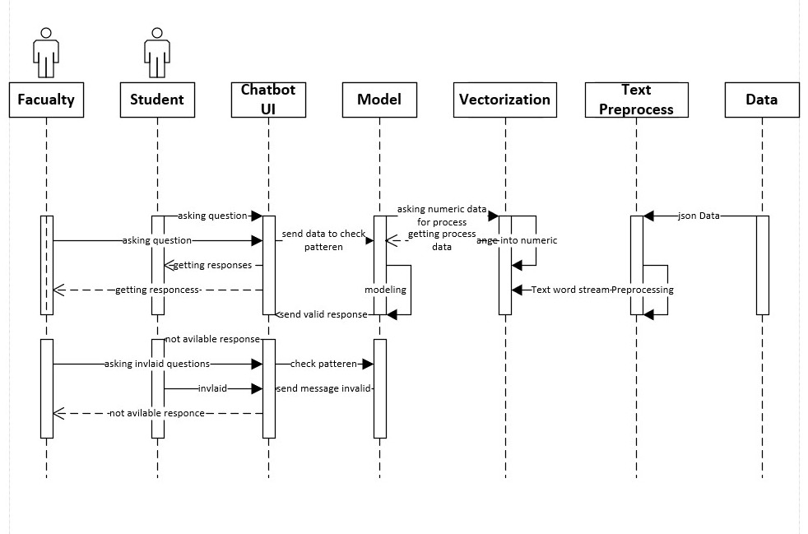

DOMAIN MODEL:

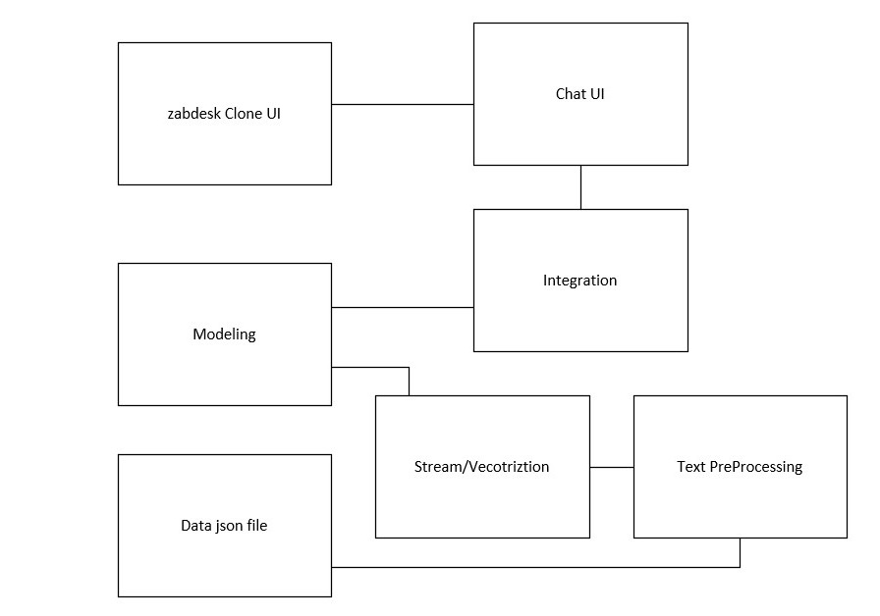

ITERATION PLAN:

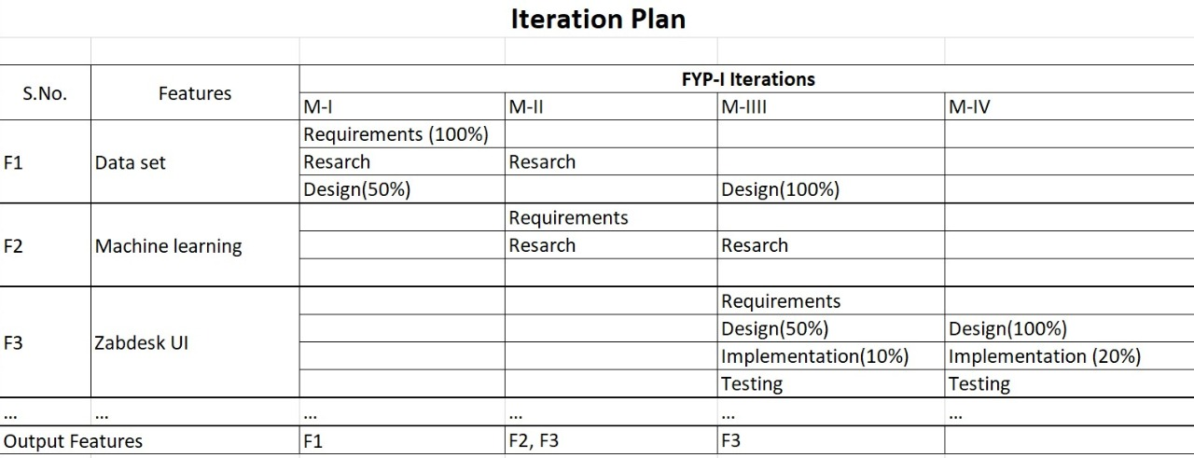

Test Cases:

|  |  |  |  |
| --- | --- | --- | --- |
| Test Case ID: | 1 |  |  |
| QA Test Engineer Test Case Version: | name 1 | Reviewed By |  |
| Test Execution Date: | 15-10-2018 |  |  |
| Use Case Reference(s) | 1 |  |  |
| GUI Reference(s) | - |  |  |
| Objective | To check web UI | |  |
| Prerequisite: | To check local server and package managers work fine | |  |
| Test Case Description | In this test case Web UI well responses and run on server | |  |
| Possible  Test Conformance  Input Parameters Expected Output Actual OutputStatus Reason(s) in case  of failure | | | |
|  | | | |

|  |  |  |  |
| --- | --- | --- | --- |
| Test Case ID: | 2 |  |  |
| QA Test Engineer Test Case Version: | name 1 | Reviewed By |  |
| Test Execution Date: | 15-10-2018 |  |  |
| Use Case Reference(s) | 1 |  |  |
| GUI Reference(s) | - |  |  |
| Objective | To check Chat UI | |  |
| Prerequisite: | Check interaction and send responses | |  |
| Test Case Description | In this test case Chat UI well responses and run on server | |  |
| Possible  Test Conformance  Input Parameters Expected Output Actual OutputStatus Reason(s) in case  of failure | | | |
|  | | | |

|  |  |  |  |
| --- | --- | --- | --- |
| Test Case ID: | 3 |  |  |
| QA Test Engineer Test Case Version: | name 1 | Reviewed By | Saad Anwar |
| Test Execution Date: | 15-10-2018 |  |  |
| Use Case Reference(s) | 1 |  |  |
| GUI Reference(s) | - |  |  |
| Objective | To check Data set format | |  |
| Prerequisite: | To check Data set format is fine with patterns, tags and responses | |  |
| Test Case Description | In this test case To check Data set format is fine with patterns, tags and responses | |  |
| Possible  Test Conformance  Input Parameters Expected Output Actual OutputStatus Reason(s) in case  of failure | | | |
|  | | | |